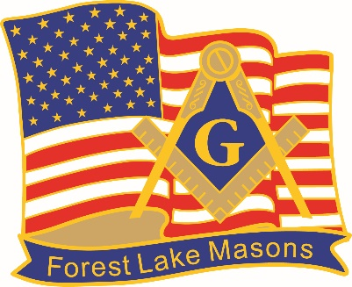
Forest Lake Masonic Lodge #344 A.F. & A.M.
Five Hundred Dollar Shared Selfless Scholarship
Open to Students of FLHS, LILA, & NLA.
Deadline Date: March 31st 2023 www.forestlakemasons.com
Nominator Information
Student Name:
Student Address:
City, State, Zip:
Email Address:
Phone Number:
Guardian Name:
Name of School:

Nominee Information
Student Name:
Student Address:
City, State, Zip:
Email Address:
Phone Number:
Guardian Name:
Name of School:

How & What to Submit
Forest Lake Masonic Lodge is pleased to announce a new scholarship opportunity for students in the Forest Lake Area School District. This new kind of scholarship which has been adopted by MN Masonic Charities as well as numerous other Masonic Lodges throughout MN is a kindness based, Shared Selfless Scholarship. This scholarship is not based in any way, shape, or form on academic achievements but solely on the kind and generous deeds of the individual. Awarded to an individual student who, recognized and nominated by a peer, has shown through one or many acts of kindness, empathy, and generosity a spirit of love and compassion that has bettered the life of another individual. In recognition of this individual Forest Lake Masonic Lodge will be awarding a $500 Scholarship to be shared by the individual who has been nominated and the individual who nominated them. An individual cannot nominate themselves. To nominate someone for this scholarship please fill out this application and submit a short essay (500 to 1000 words) explaining who this individual is and their specific actions which make them worthy of this nomination. Please submit this application by mail to the Forest Lake Masonic Lodge, 119 8th Ave SE, Forest Lake, MN 55025 or by email to forestlakemasons@gmail.com.
Thank You, Forest Lake Masonic Lodge #344

